# CS 340 Austin Animal Care Web Application README

## About the Project/Project Title

In project 2, a dashboard for Austin Animal Care’s application was developed using Python and the Dash Framework. This dashboard contained data from the Austin Animal Care database collection in the form of a table, chart, and geolocation map. In order to effectively glue the model to the view, the CRUD module developed in project 1 as well as the Pandas API were employed in the controller. The Austin Animal Care web application’s dashboard implements a user-friendly interface and has widgets that help users filter the data by types of rescue dogs.

## Motivation

MongoDB is commonly used in many different applications as the base level or model component where numerous types of data are stored. However, in order to efficiently utilize databases, a middle-ware layer is often required in a stack that connects the application to the database. Fortunately, Python provides the PyMongo driver for MongoDB that can efficiently connect the server level of the database to the client-facing applications. In project 1, create, read, update, and delete (CRUD) functionalities were developed in Python to effectively “glue” the database layer with the client-facing layer. The CRUD module will effectively allow users to create, read, update, and delete documents from the client-facing layer instead of the database layer. This will provide an abstraction so that the users do not have to deal with the complexities of having to implement CRUD from the database layer.

In order for users at Grazioso Salvare and Austin Animal Care to access the database, a client-facing web application dashboard is necessary. The dashboard will be the primary method for users to access and interact with the database and CRUD module developed in project 1. Therefore, in project 2, the client-facing layer was developed using Python, the Dash framework, and Pandas for its data table data structure. The Dash framework provides a layout API that can be used to efficiently create the HTML and CSS logic required for a webpage. The Dash framework also provides core components that handle JavaScript and callback logic for users to interact with the dashboard. The Pandas library was necessary in order to load the data from the AAC database collection into its prebuilt data table. The Pandas’ data table provided an abstraction from the logic of transferring data from the database to a data structure and casting said data to a viewable format.

In order to best serve users of an application, the implemented code should be maintained. In this project, only CRUD methods were implemented, which do not require as much maintenance compared to the database server level. For example, as the database grows, developers should begin to think about vertical and horizontal scaling to reduce the load on said servers. In order to enhance the speed of CRUD queries, developers should also create indexes.

## Getting Started

In order to get a local copy up and running please follow the steps below:

* Ensure that the MongoDB database is up and running by executing “/usr/local/bin/mongo_ctl start” in the terminal. The terminal will return the port number as well as the Unix_Socket location.



* Now, open Jupyter Notebook, where you will find a folder named “Project1” on the desktop.

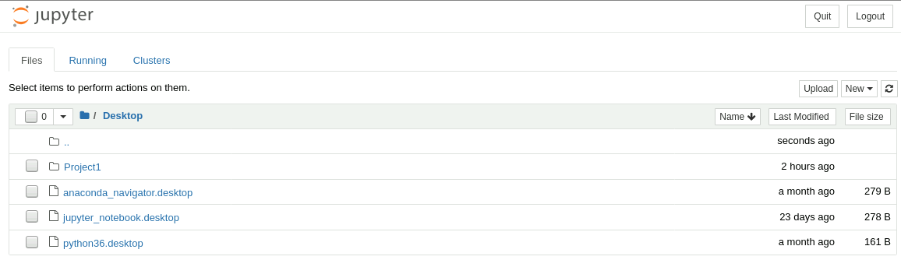

* Go inside the “Project1” folder, where you will find both the ProjectTwoDashboard.ipynb and the animal_shelter.py file. The ProjectTwoDashBoard.ipynb contains the logic for the application’s layout and controller logic for loading and filtering data based on callbacks. The animal_shelter.py file contains the logic for authenticating with the database, creating a document, reading a document, updating a document, and deleting a document.

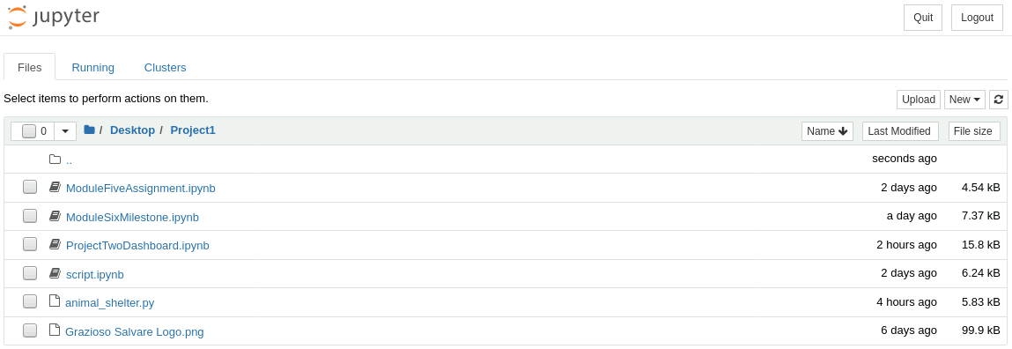

* Open the ProjectTwoDashBoard.ipynb file and run the cell that contains the dashboard’s logic.

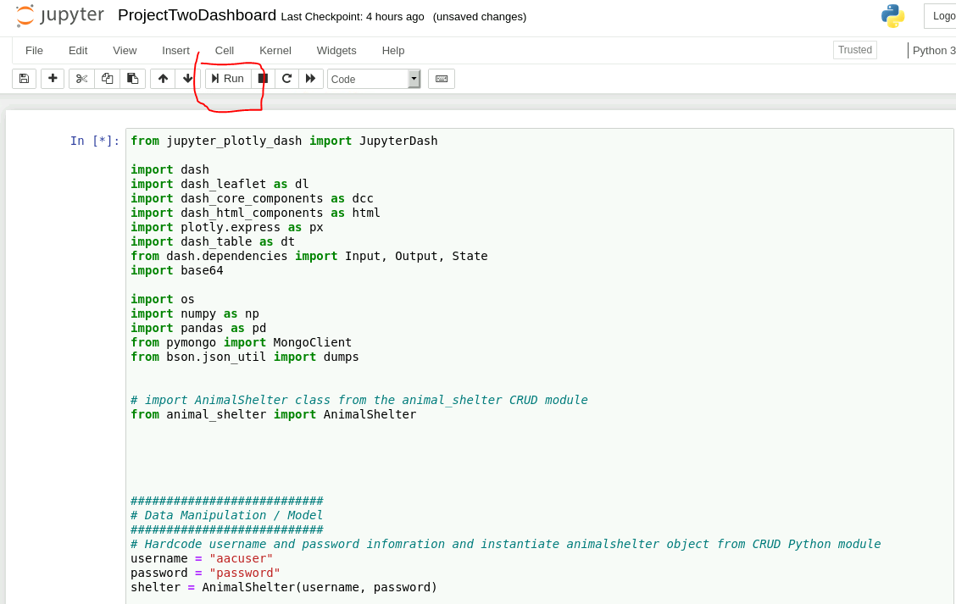

* You can view and interact with the application at the bottom of the cell or open the application in a new window (recommended).

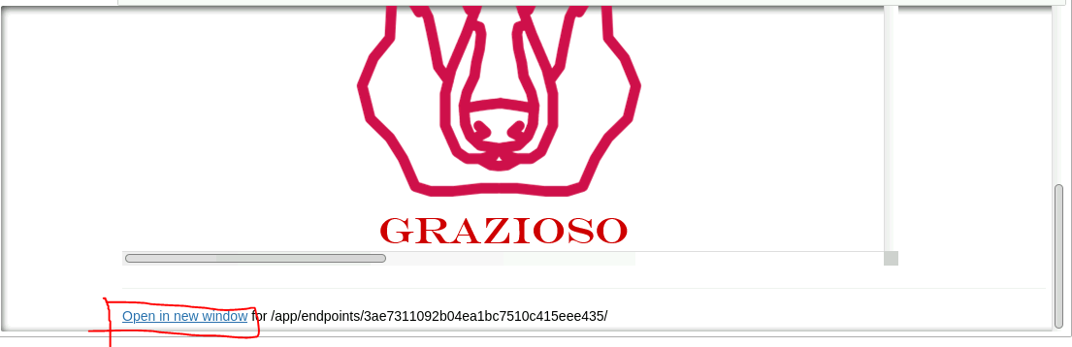

* Opening app in a new window will bring up the dashboard in a new window with URL “http://localhost:8890/app/endpoints/3ae7311092b04ea1bc7510c415eee435/”. However, this exact endpoint may differ.

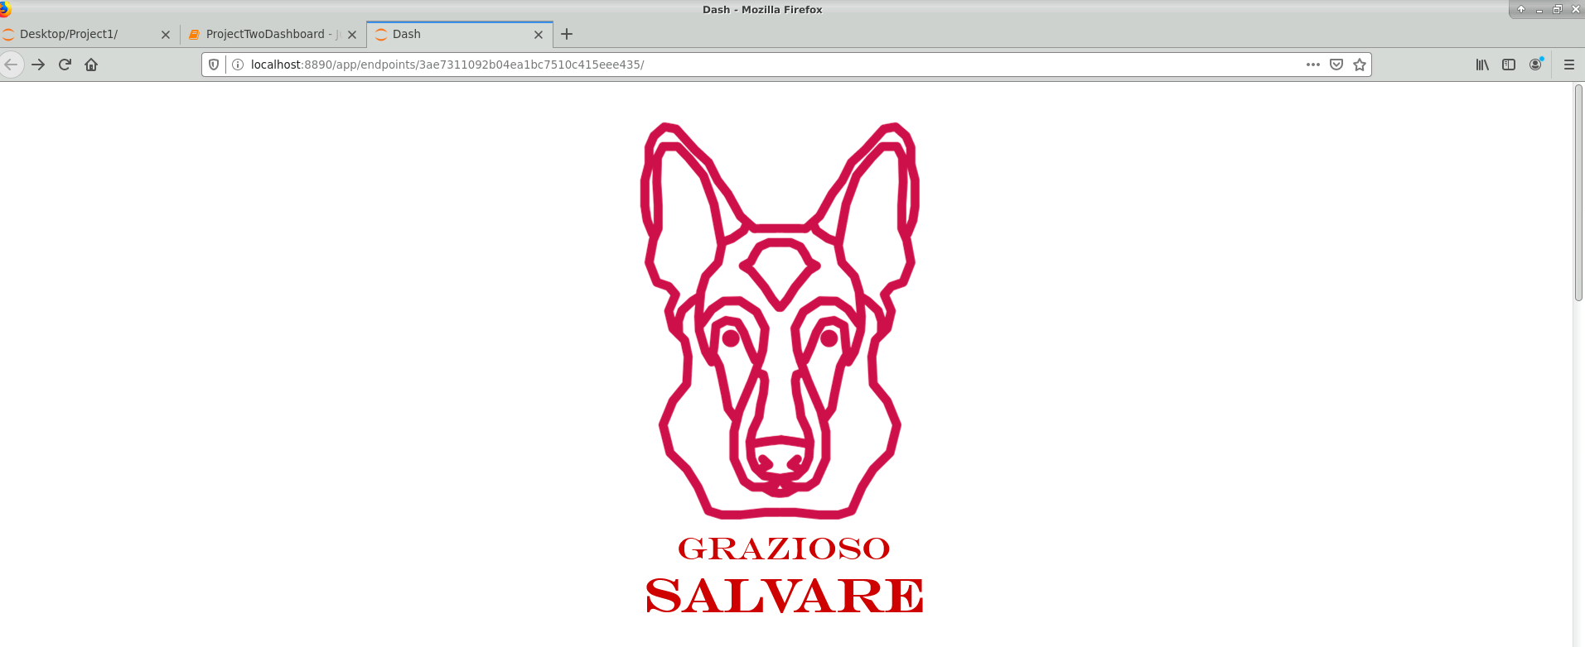

* The startup of the application is now complete, and features and interactions with the application can be found in the “Usage” section.

**Required Functionality**

The required functionality were based on the Dashboard Specifications Document provided by the UI/UX developer at Global Rain and can be found within the same project folder. The first requirement was that the dash board be branded with Grazioso Salvare’s logo and that the logo be a URL anchor tag to the client’s home page: [www.snhu.edu](http://www.snhu.edu). The next requirement was that a unique identifier be added to the dashboard in the form of text or an image. The image below shows the inclusion of the logo linked to the client’s home page as well as a unique identifier:

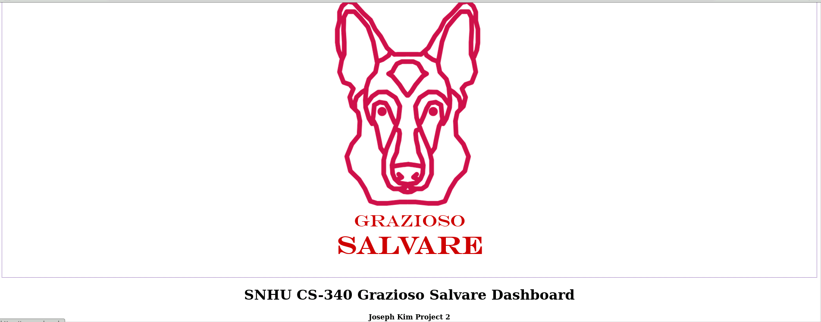

In order to develop this functionality, the image was first loaded and encoded into base 64. Then within the Dash framework’s app.layout, the html.A function was called to create an anchor tag with an href of “https://www.snhu.edu”. The children property for the anchor tag was then defined that contained the html.Img function that contained the image information. In order to implement a unique identifier, within the html.Div, an html.H1 was added for the tilte and an html.H4 was added for the unique identifier. Both of these header tags were bolded and centered with html.B and html.Center, respectively. The screenshot shows the logic for the image, link to the homepage, and a unique identifier:

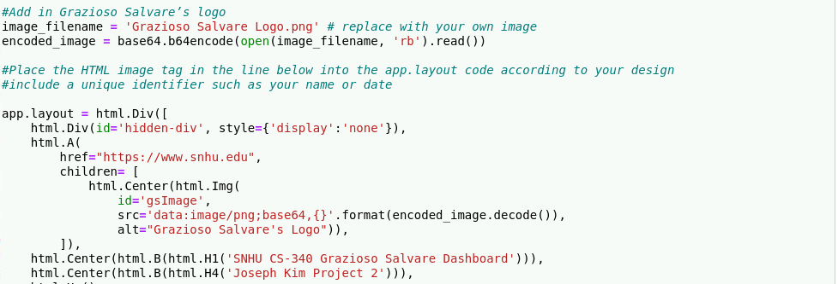

The next required functionality was an interactive filtering option widget to filter the Austin Animal Center Outcomes data set by different types of rescue dogs. The widget also required the ability to change the data set back to an unfiltered state. The screenshot below shows an interactive filtering option widget in the form of radio buttons in the unfiltered state:

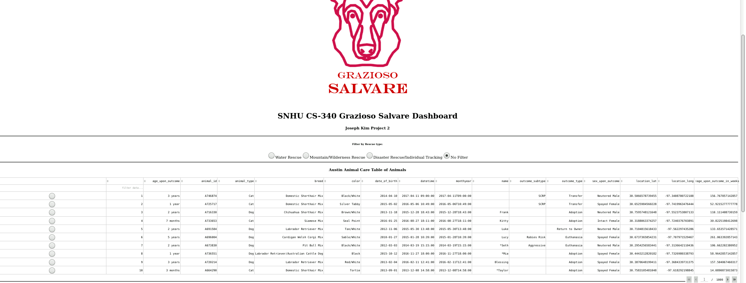

The screenshot below shows the interactive filtering radio button widget filtering the data by water rescue dogs:

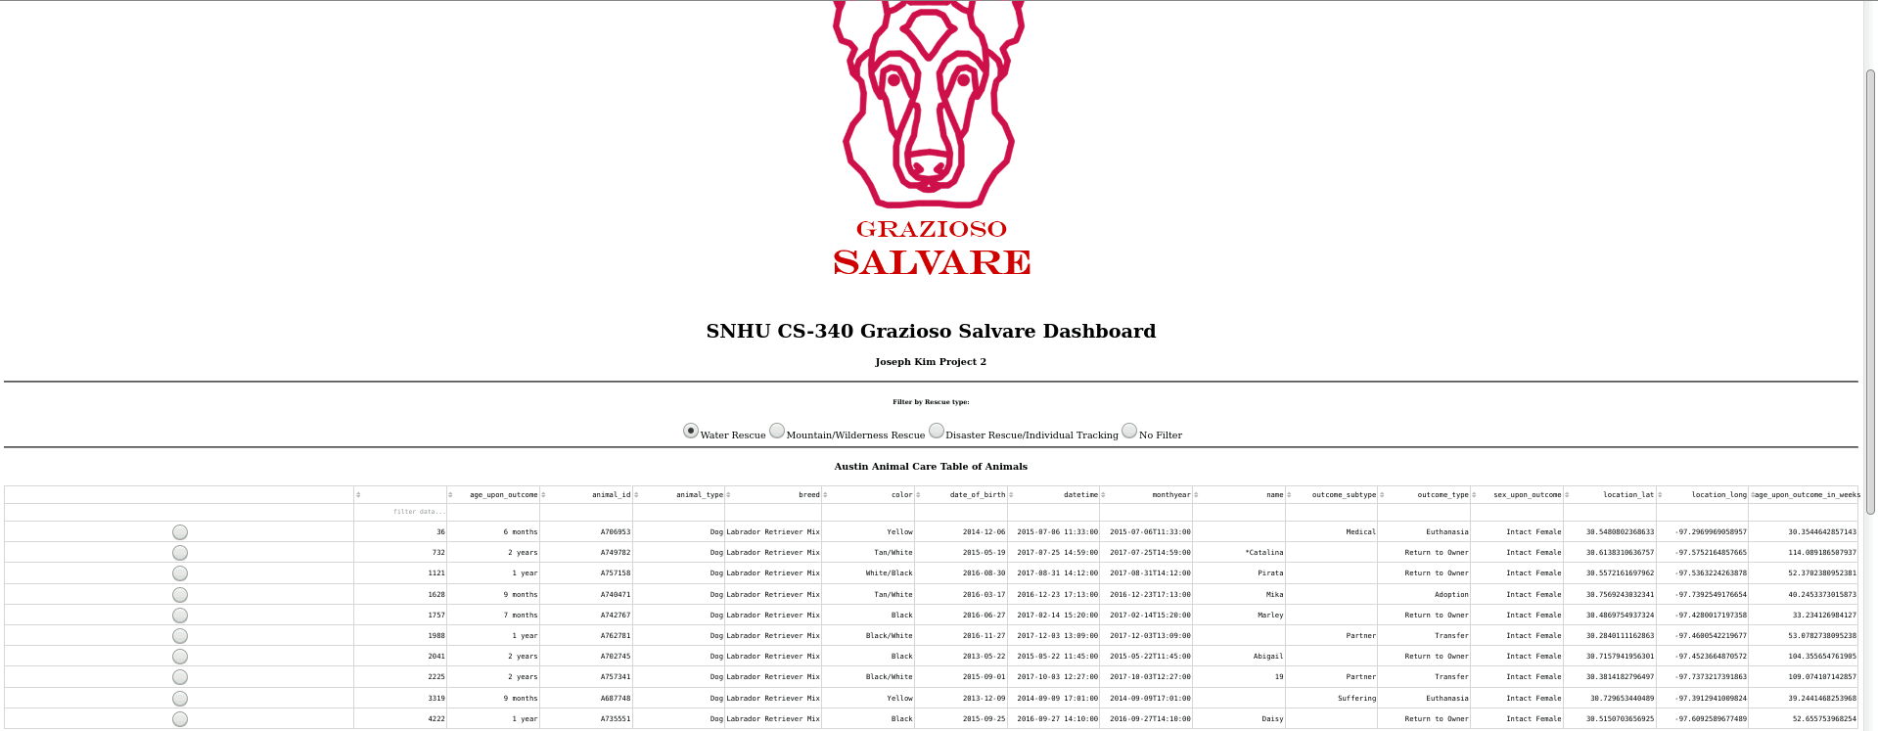

The screenshot below shows the interactive filtering radio button widget filtering the data by Mountain or Wilderness Rescue dogs:

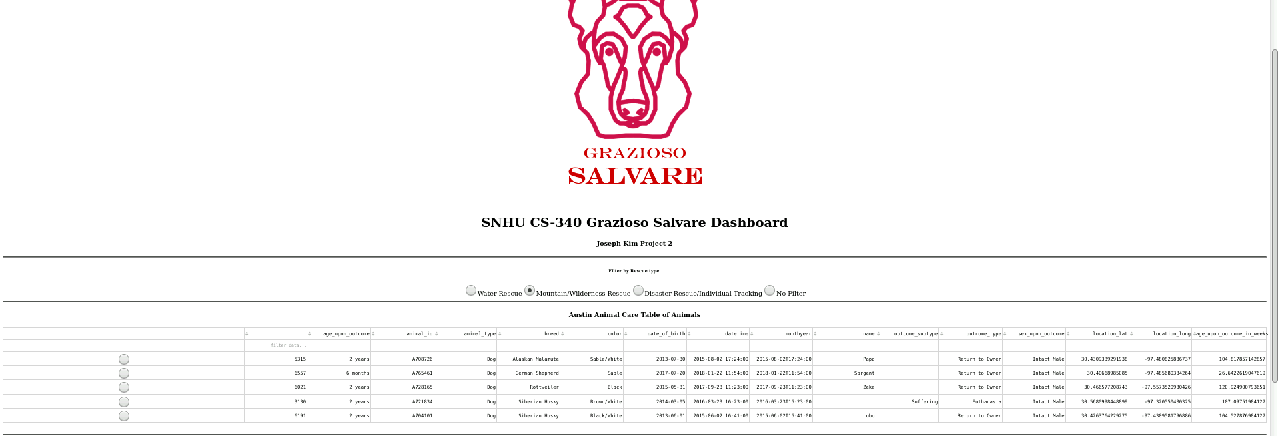

The screenshot below shows the interactive filtering radio button widget filtering the data by Disaster Rescue or Individual Tracking Dogs:

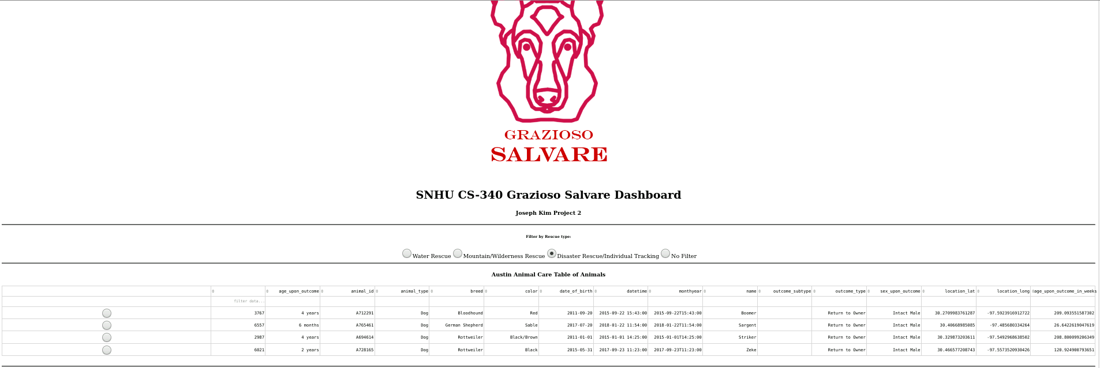

In order to develop the interactive filtering options, radio buttons were first implemented in the app.layout section of the dashboard. Interactive radio buttons were created using Dash’s core components library, dcc.RadioItems(). Within the radio items component, an id was assigned as “radio-items” to be a unique identifier, which would be necessary for callbacks functions. Then the options were set for the labels, which specified each type of rescue dog for the buttons, and the associated values that each one. The starting value was set to “No”, which specified an unfiltered state to start. The screenshot below shows the code that creates the radio buttons used for filtering the data:

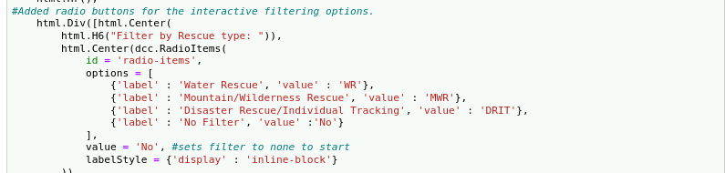

Next, a data table that loaded the Austin Animal Care data from the database to the client-facing layer was developed. The data table component was imported from dash and used as dt.DataTable(). Within dt.DataTable(), an unique identifier was given using id and was assigned the value “datatable-interactivity, which would be needed for callback functions. Then the column property and values were set and the data was loaded using Panda’s DataFrame data structure and functionality. The data was first loaded at the beginning of the app with pd.DataFrame.from_records(shelter.read({})), which read and loaded the AAC data from the database using the CRUD functionality developed in project 1. In addition, data frames passing in the filtering parameters were created at the beginning of the application to prevent this expensive operation to be done within a callback. A read_filtering method was implemented in the CRUD module previously created in project 1. The function took in the filtering options are arguments and used PyMongo’s functionality to efficiently find the documents that matched the query. The syntax of the query can be found in the function’s definition that is included in the screenshot below. Then within the data table, the read in data in the form of records were converted to a dictionary using df.to_dict(‘records’). Then features for the data table were set such as options around filtering, sorting, and selecting. The screenshots below shows the read_filtered function definition, the creation of the data frame as well as the data table:

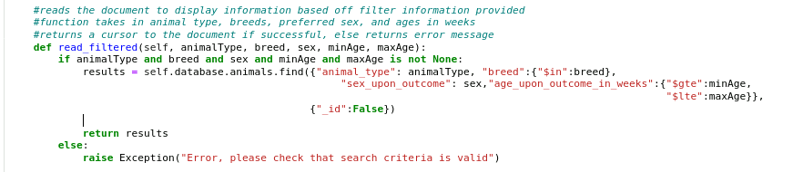

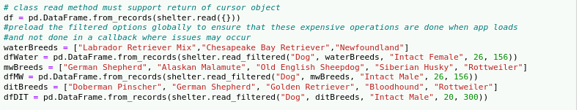

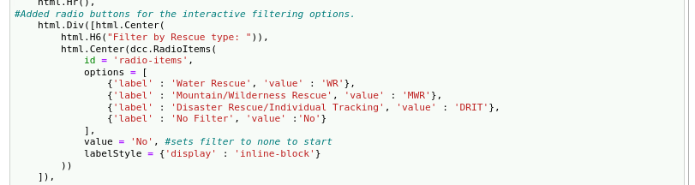

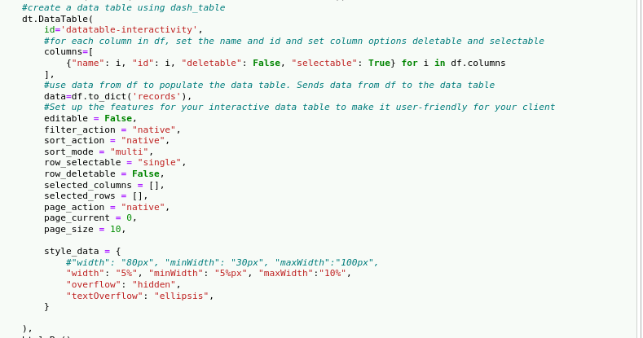

Then, in order to allow the radio button’s filtering options to be responsive in updating the data table, a callback function was developed. First, the @app.callback decorator was defined to take the radio button’s value as input. Then the callback’s output was defined to output component properties data and columns to the data table. The function update_dashboard(filter_type) was then defined where depending on the radio button’s value or filter_type, the appropriate preloaded data frame was chosen to be the new data frame. The columns and data, dependent on the preloaded data frame, variables were returned to the “datatable-interactivity” component in the app.layout. The screenshots below show the callback function:

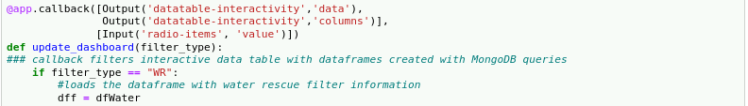





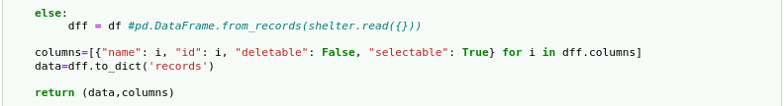

The next required functionality was a chart that dynamically responded based on the filtering options. In this dashboard, a pie chart was chosen as the chart to display the types of breeds shown in the current data table. The screenshots below show the filter type and the corresponding pie charts that shows the distribution of breeds based on the viewport of the data table:

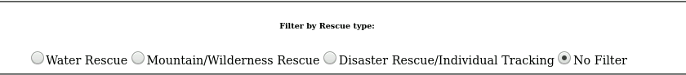

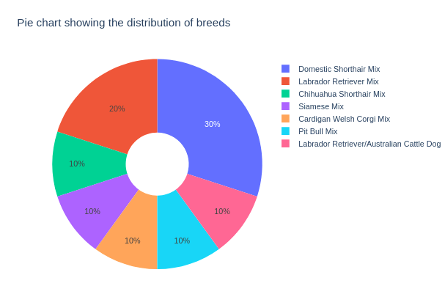

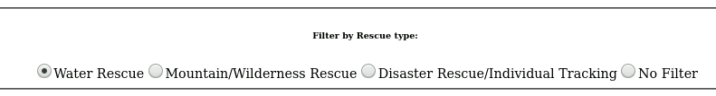

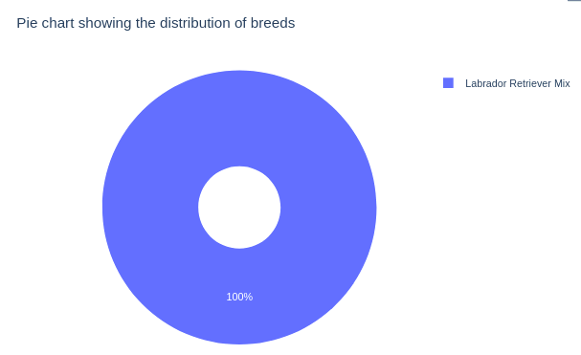

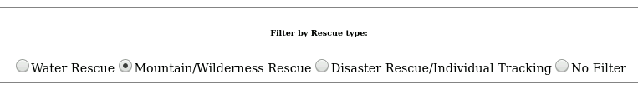

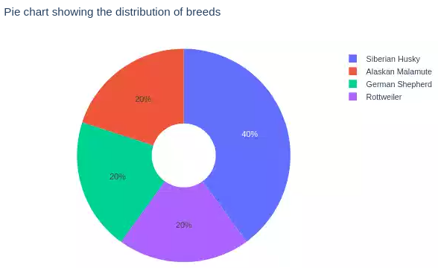

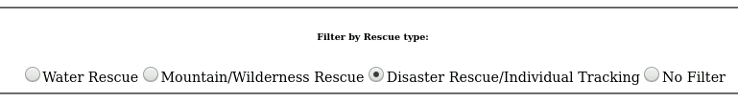

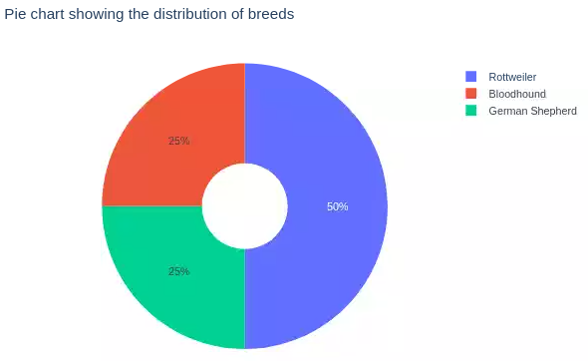

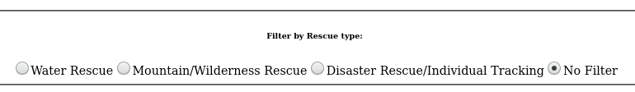

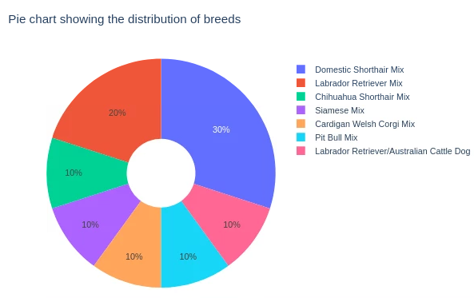

In order to create a pie chart, a location in the app.layout was defined. Within a html.Div(), a dash core component, dcc.Graph(), was implemented with the unique identifier of “graph-id” to be a placeholder for the graph figure that would be returned from a callback function. Next, a callback function was defined to take input from the data table using its unique identifier, “datatable-interactivity” and a component_property of “derived_viewport_data”. The “derived_viewport_data” is important as it will take the data based on the filtering option set from the radio buttons. The output was then defined as the unique identifier for the placeholder, “graph-id”, and its component_property set to “figure”. Within the update_graphs(viewData) callback function, the data frame was assigned using Panda’s data frame functionality to the current view data from the data table. the plotly.express library was then employed to create a pie chart with px.pie(). Within the px.pie() function, the data frame was set to the previously loaded data frame and the variables to show in the pie chart was set to “breed” using names = dff[“breed”]. The screenshots below show the code within app.layout that is a placeholder for the pie chart as well as the callback function to create and update the pie chart:

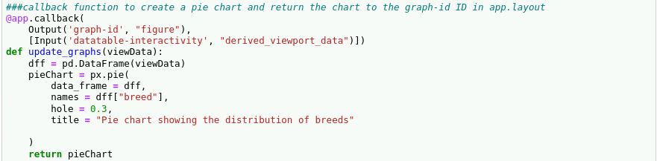

The final functional requirement of the dashboard was to create a geolocation map that dynamically responded to the filtered data table and/or a selected row. The screenshots below show the different geolocations mapped based on the filtered state or a selected state of the data table:

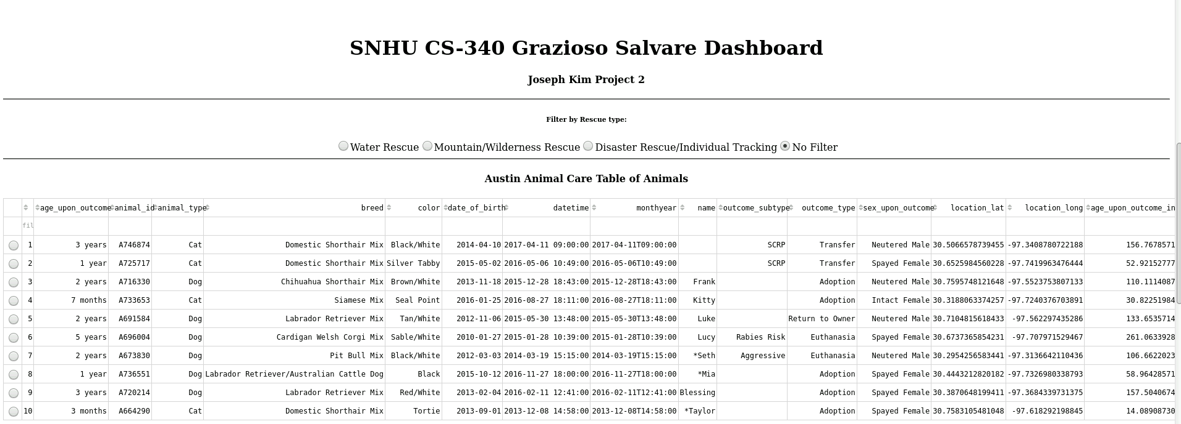

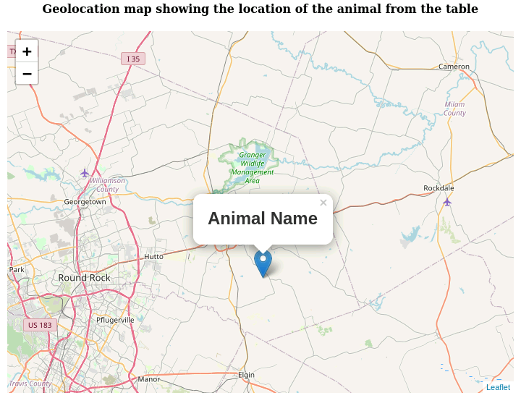

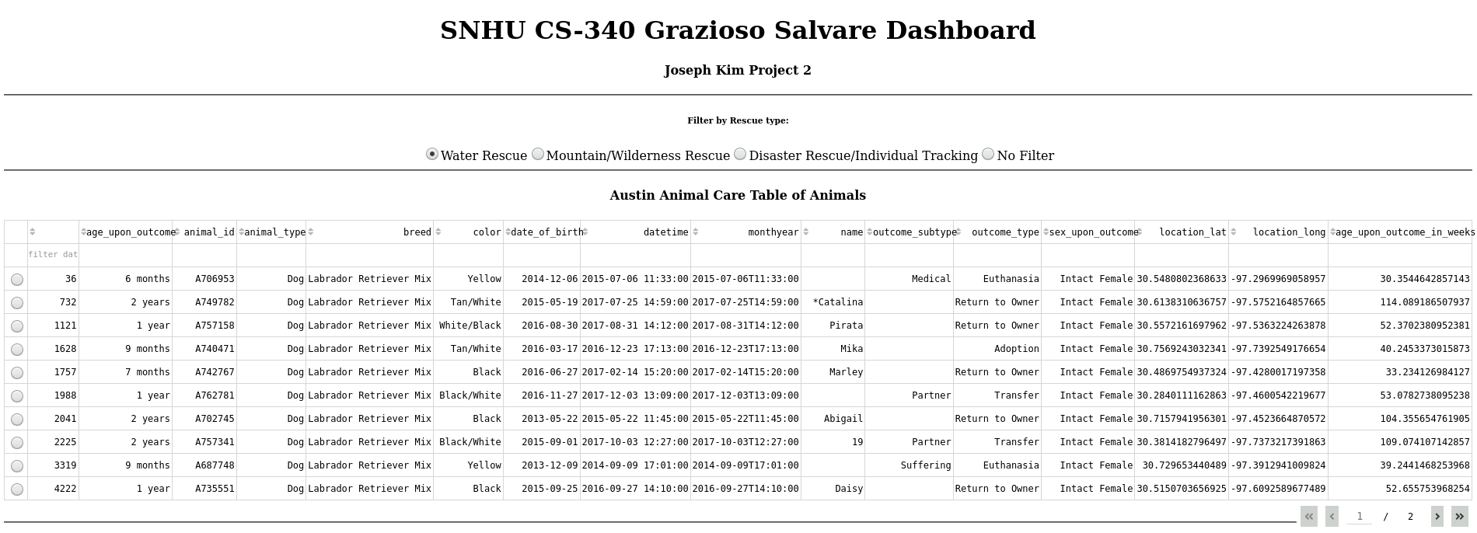

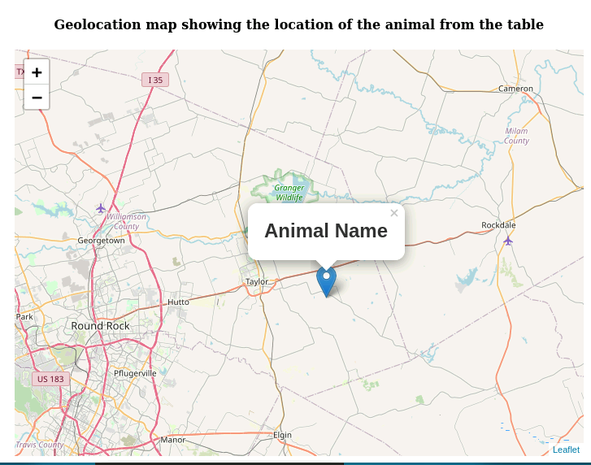

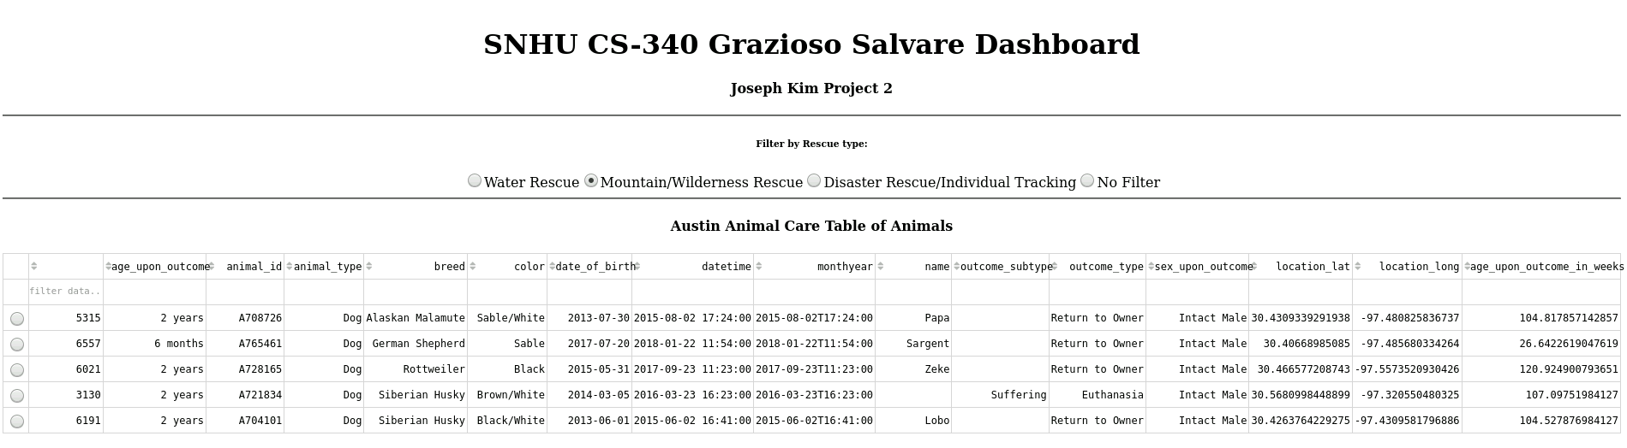

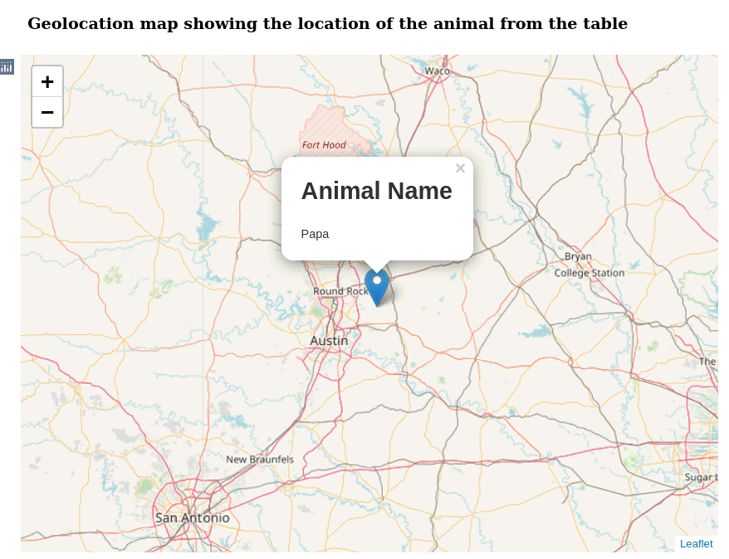

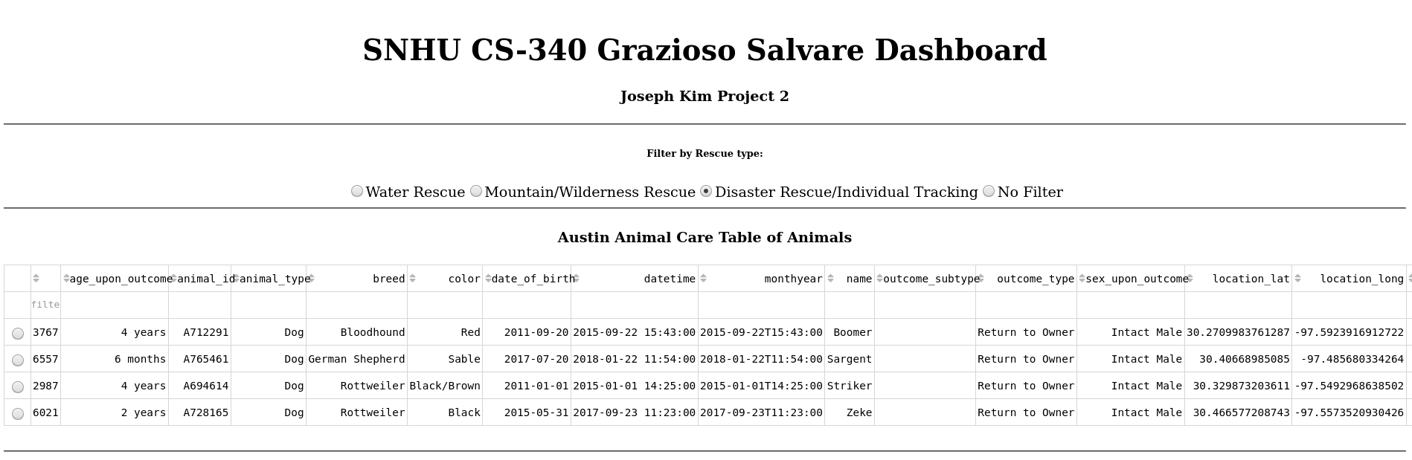

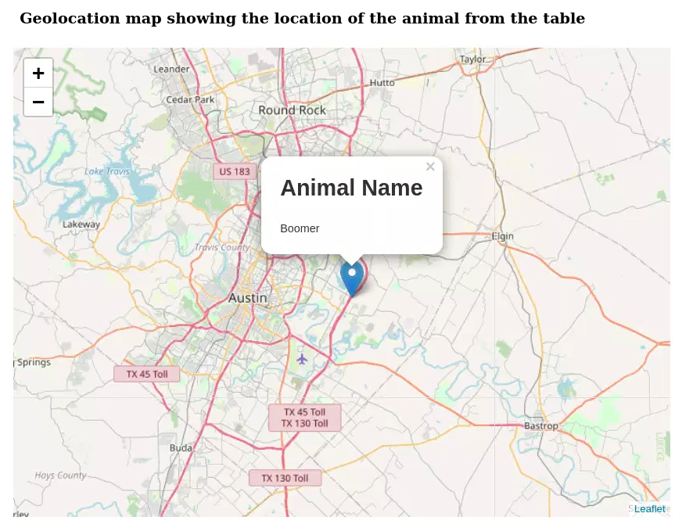

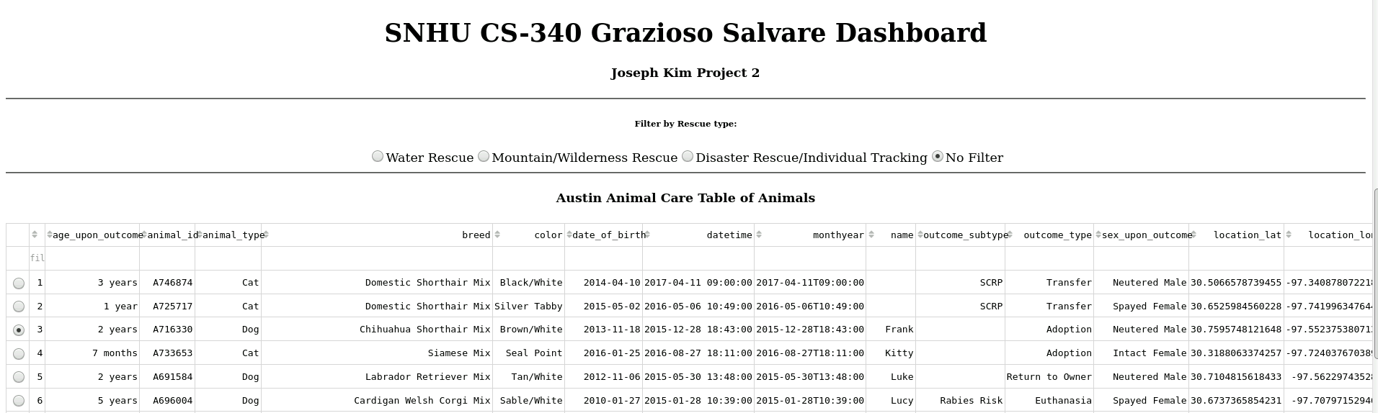

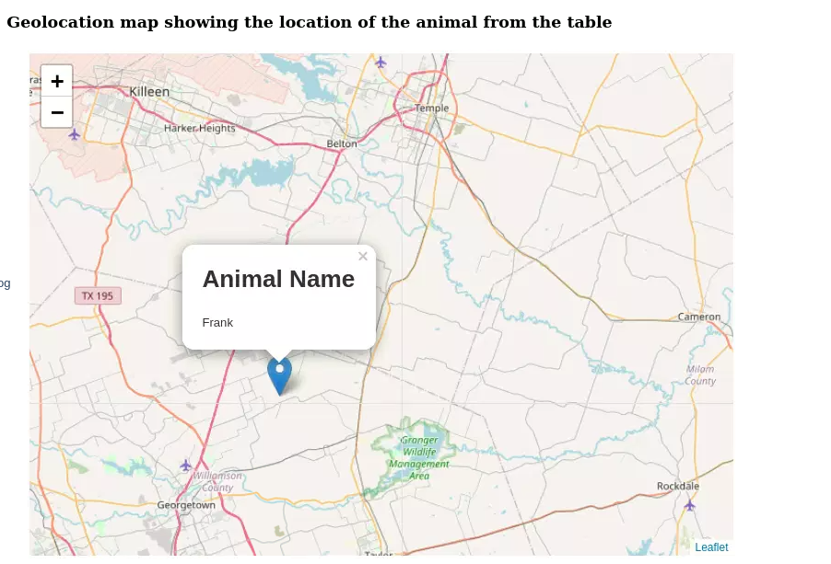

In order to develop a geolocation map that dynamically responds to the radio button’s filtering option as well as a user selected column, the location of the map first needed to be defined within app.layout. In app.layout, an html.Div() component was defined with a unique identifier of “map-id”, which would be a placeholder for the map that would created and returned by a callback function. A callback function was then defined that took in inputs from the datatable-interactivity identifier in the property components of “derived_viewport_data” and “derived_virtual_selected_rows”. Then the callback function would output a child of the div placeholder defined as map-id. Within the callback function, update_map(viewData, derived_virtual_selected_rows), the function would first create a data frame based on the viewport data, where the map always displays the animal on the first row unless the user selects a specific row. To implement said logic, the code first checked to see if a user had selected a row. If no row was selected, the data frames latitude, longitude, animal breed, and animal name was set to be the first row using the iloc functionality. If a user selects a row, the derived_virtual_selected_rows component property list would be used to pass in the row’s integer to the latitude, longitude, animal breed, and animal name. The function would then use the Dash’s Leaflet library to create and return a map. Within the dl.Map() component, the center of the pin was defined as the previously assigned latitude and longitude. The dl.Marker() component was used to define that the tooltip show the animal’s breed and dl.Popup() was used to show the animal’s name. the screenshot below shows the code implemented to assign a position for the map in app.layout as well as the logic to create said map:

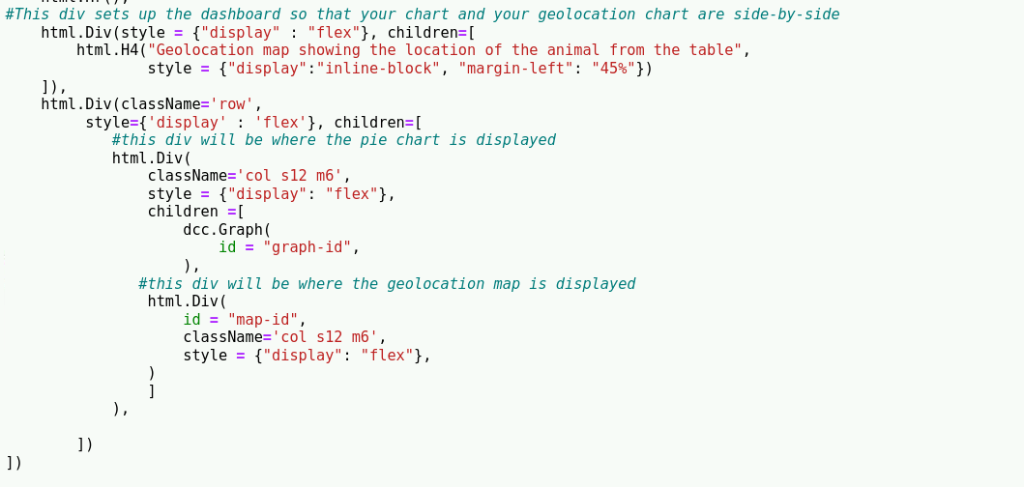

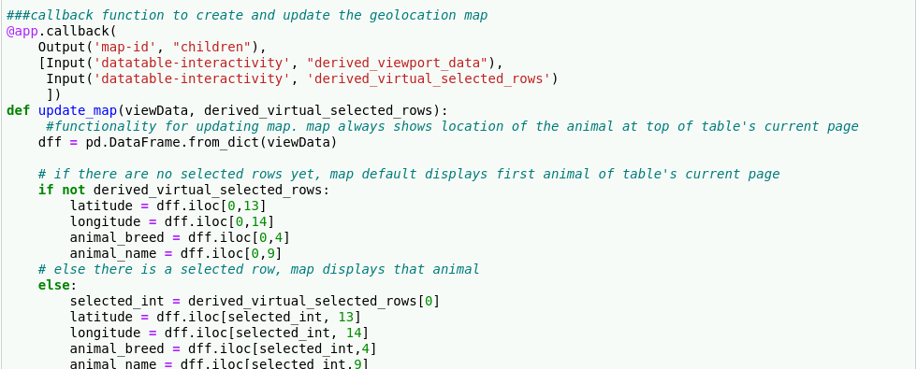

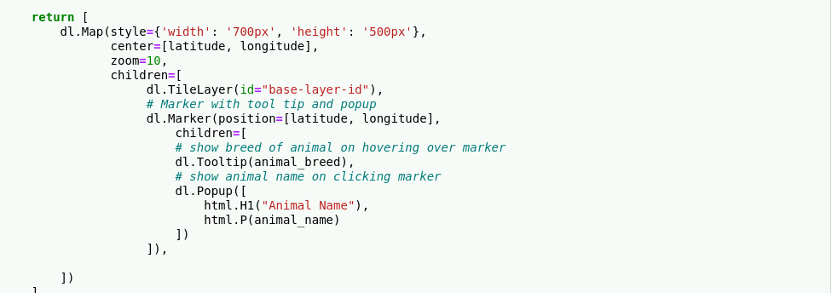

## Installation

The necessary tools are listed below:

* MongoDB version 4.2.6 is the database being used and to install it please refer to their website mongodb.com.
  + MongoDB is a not only SQL database and is perfect for holding data in non-uniform formats and data structures such as a dictionary. Austin Animal Center’s data is somewhat disorganized and the labor to create tables and joins in a RDMS would be an extensive process. Therefore, MongoDB is a great choice for creating and maintaining their data.
  + MongoDB is a great model component for development of web applications as it has the PyMongo Driver that makes communication between Python and MongoDB seamless.
* Python version 3.6 is the scripting language that was used to create the animal_shelter.py and script.ipynb. Please refer to their website python.org/downloads/ for installation.
  + Python is an easy to use and efficient language for development. In addition, Python provides PyMongo which contains tools for working with MongoDB. PyMongo provides libraries for make connecting to MongoDB efficient. In addition, it also provides libraries for TLS/SSL, Client-Side Field Level Encryption. Python also has libraries that abstract Binary JSON functionalities that are needed for MongoDB. Therefore, the use of Python and its libraries is a good choice to create a CRUD module that connects the user level with the database level.
* PyMongo Driver version 3.10.1 was used and is the official driver to efficient work with MongoDB from Python.
  + The PyMongo Driver provides useful functionalities that were used in order to create the CRUD module. MongoClient, provided by PyMongo, allows for efficient connection and authentication of users from the client-side while developing using Python.
  + The PyMongo Driver also translates commonly used CRUD operations from the MongoDB shell to Python.
* Dash Framework can be installed in the terminal with “pip install dash” or “pip install jupyter-dash” for Jupyter Notebook users.
  + The Dash framework provides functionalities, in the form of components, to create a user interface while abstracting the details of HTML, CSS, and JavaScript. The framework provides a html components library as well as a core components library. The html components library contains all of the functionalities needed to create the layout of the view component of the application. The core component library contains all of the functionalities needed to create dynamic and interactive components in the layout of the view component.
  + The Dash framework also provides the ability to create callback functions that allow for efficient controller logic for a web application. By providing a callback decorator, callback functions can be defined using unique identifiers and their component properties to define the inputs and outputs of the function. The framework abstracts the intricacies of dynamically updated the web page based on user input.
  + The Dash framework also provides a Leaflet library that is needed to create a geolocation map. Developers can quickly implement a geolocation map using the predefined properties provided by Dash.
  + For more information on the dash framework, please visit their website: https://dash.plotly.com/
* The Pandas library can be installed in the terminal with “pip install pandas”.
  + Pandas is a data analysis and manipulation tool that is built on top of Python. It provides the necessary logic and data structures to import and display the data from the AAC database as a data table.
  + For more information on Pandas, please visit their website: https://pandas.pydata.org/
* Jupyter Notebook was used for the integrated development language environment (IDLE) in order to develop the create and read functionalities. For more information on installation, please visit their website jupyter.org/install.
  + Jupyter Notebook provides a somewhat user friendly development environment for users. Jupyter provides additional tools for developers that can help speed up development.

## Usage

The ProjectTwoDashboard.ipynb file provides the view and partial controller logic for the model component. The animal_shlter.py file provides the rest of the controller logic for the MongoDB model, which includes connecting to the AAC’s animal collection as well as authentication and authorization to the AAC database.

After opening the web application in a new window, based on the “Getting Started” section, the first functionality provided is the logo link to the SNHU homepage. The screenshot below attempts to shows clicking on the logo takes the user to SNHU:

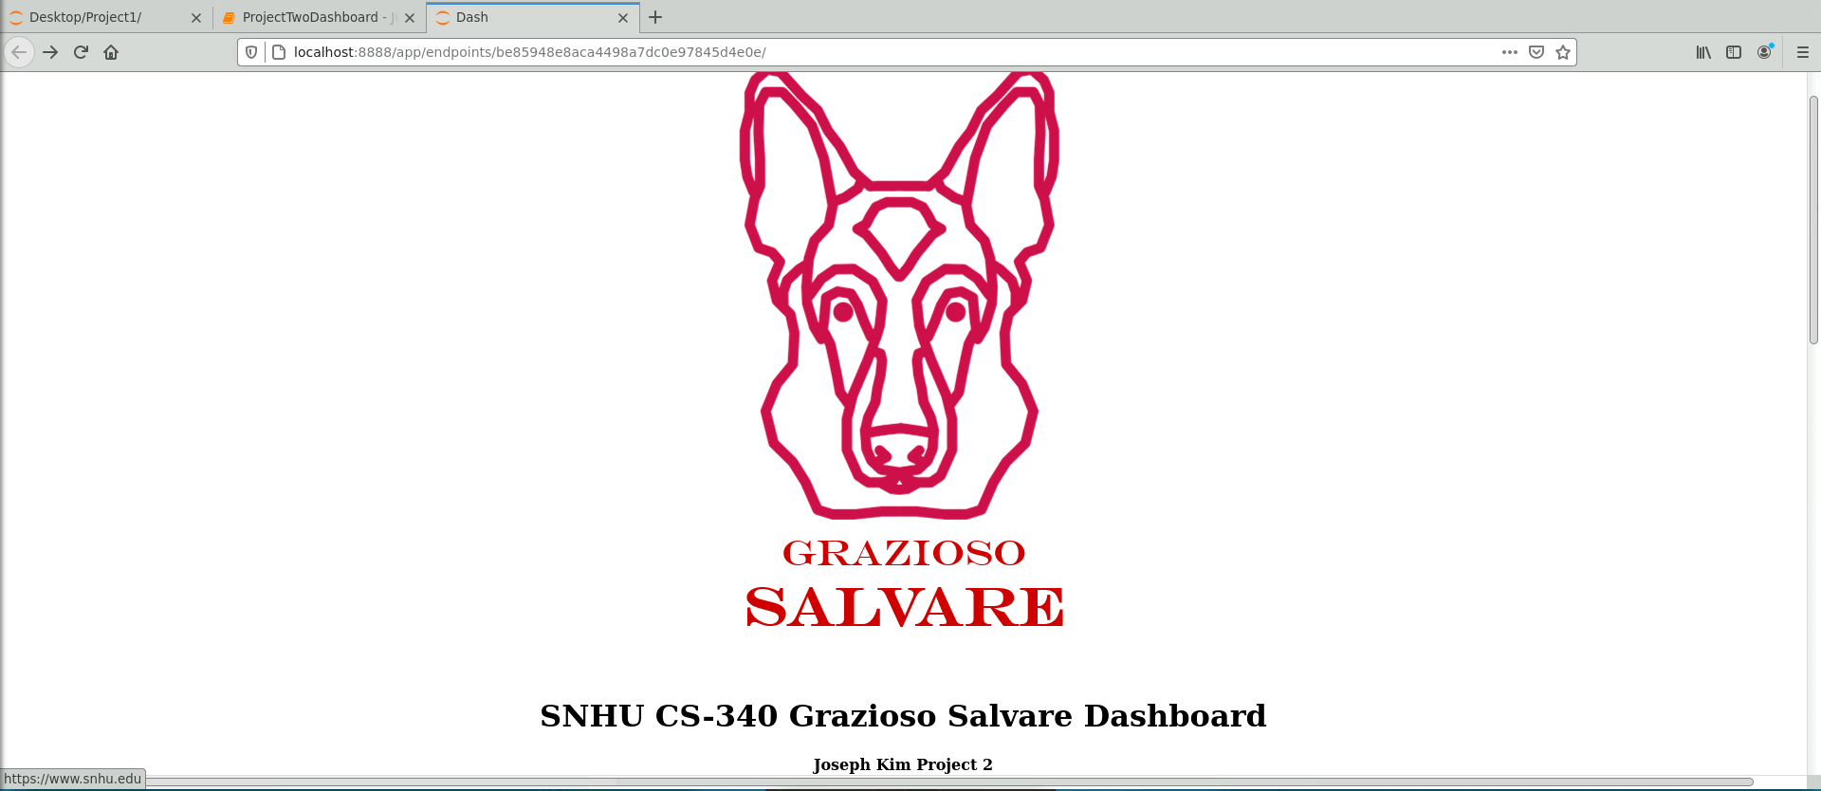

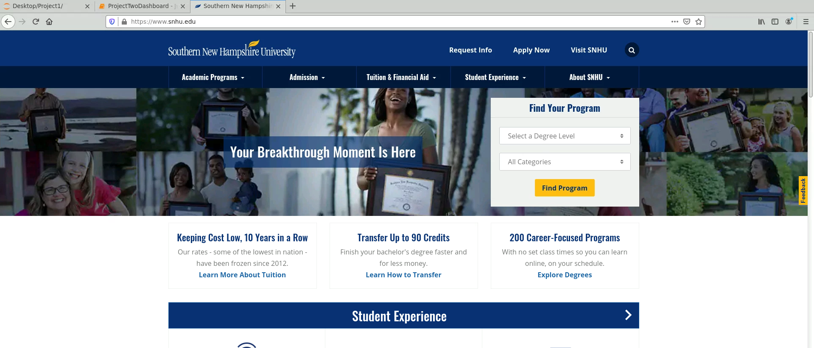

The next functionality, the radio buttons, allow a user to filter the animals by dogs and their rescue type. There are four radio buttons provided: Water Rescue, Mountain/Wilderness Rescue, Disaster/Individual Tracking, and No Filter. The screenshots below show the radio button selections and their corresponding data table, chart, and map:

Filter type – No Filter:

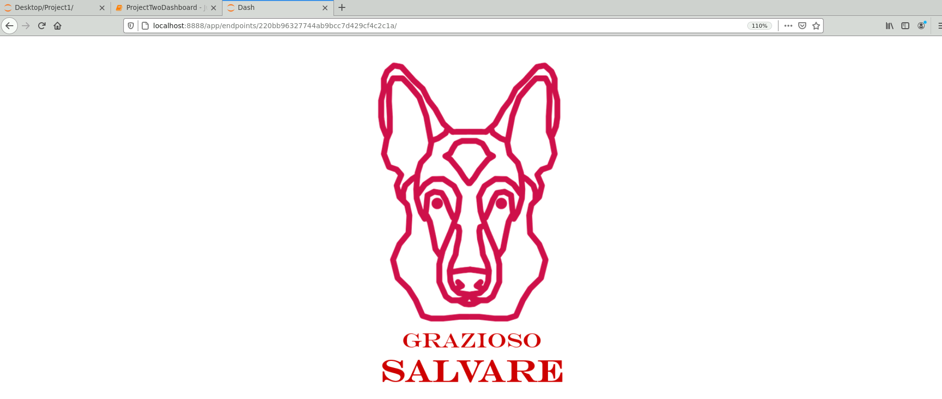

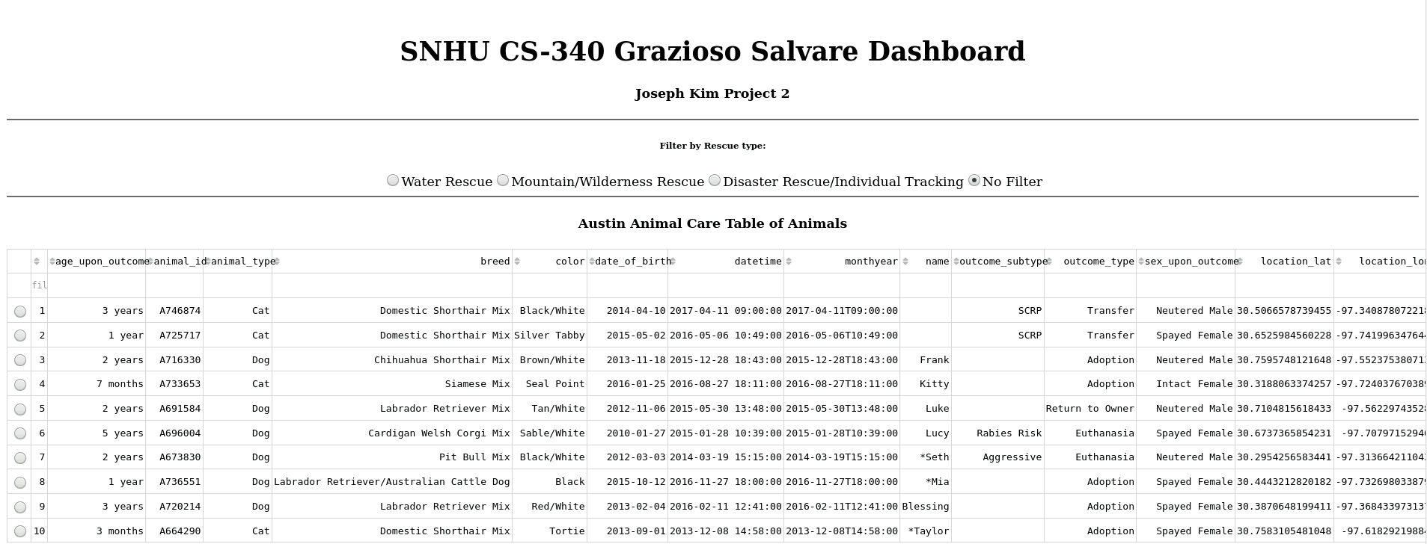

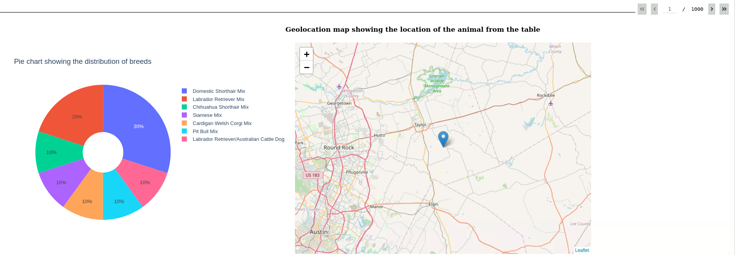

Filter type – Water Rescue:



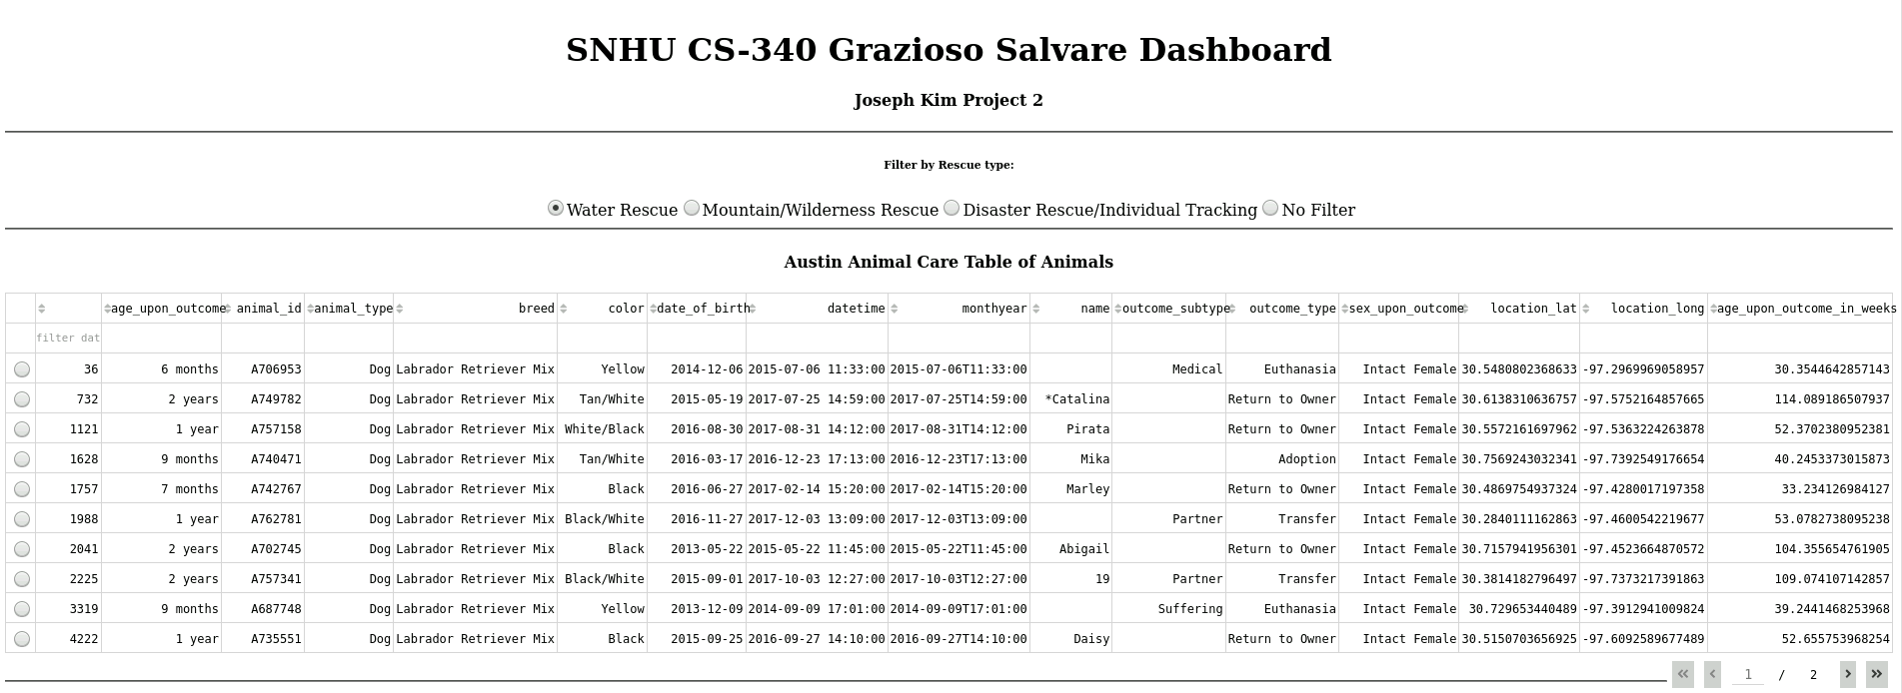

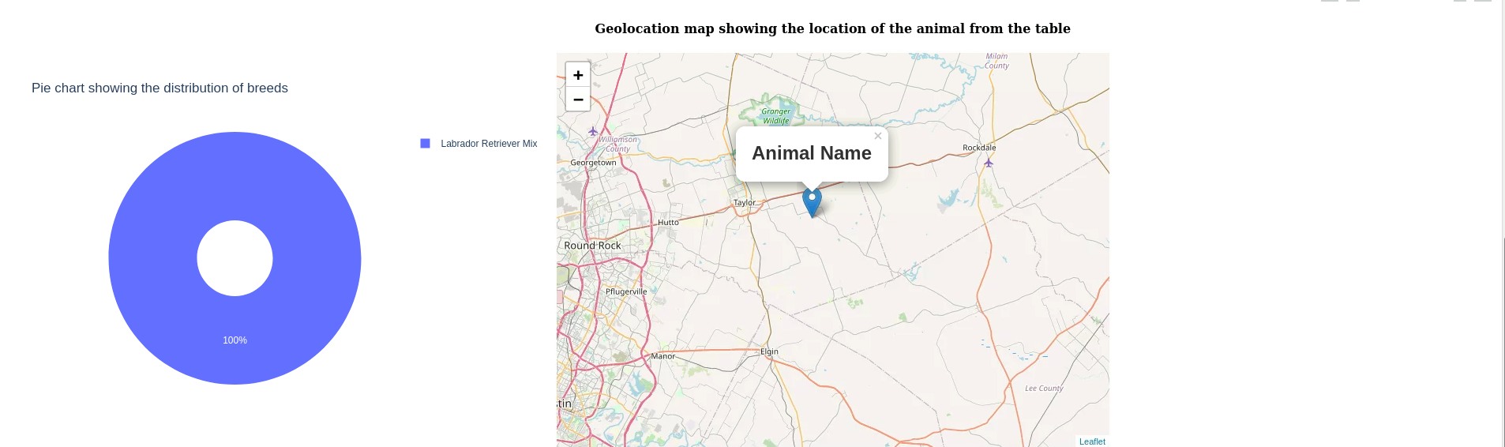

Filter type – Mountain/Wilderness Rescue:



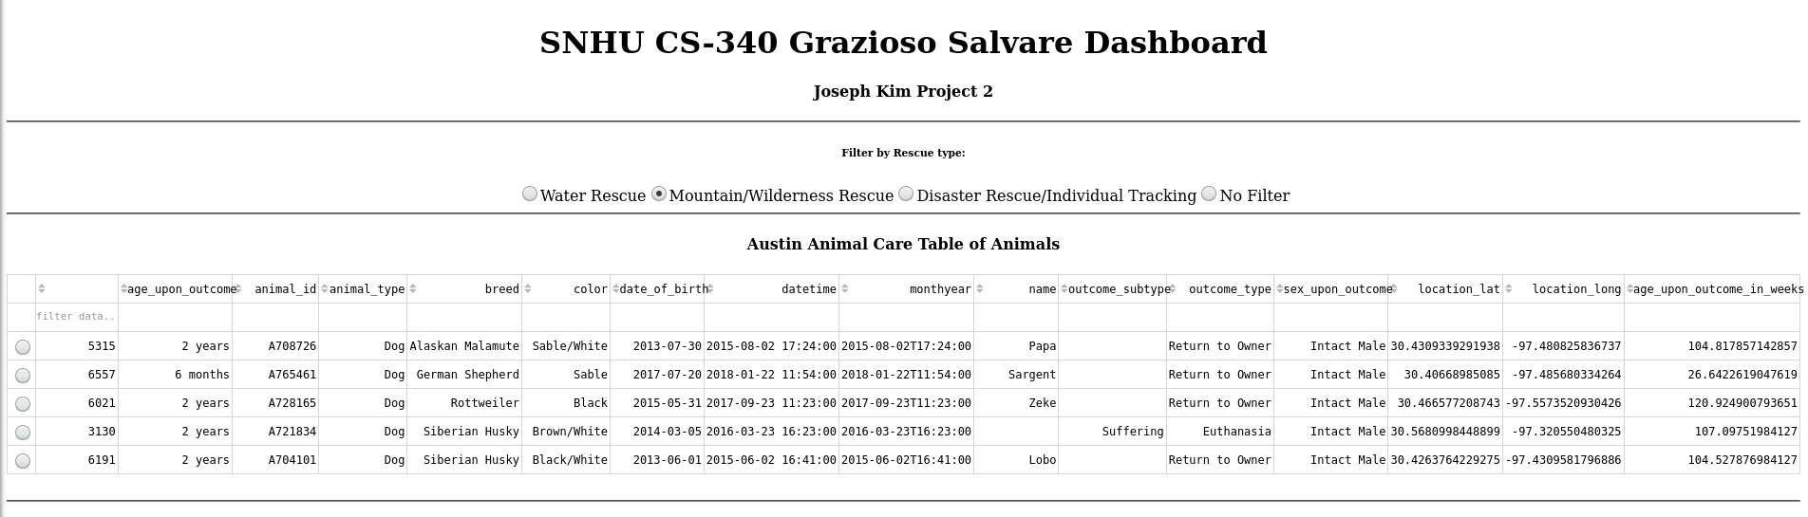

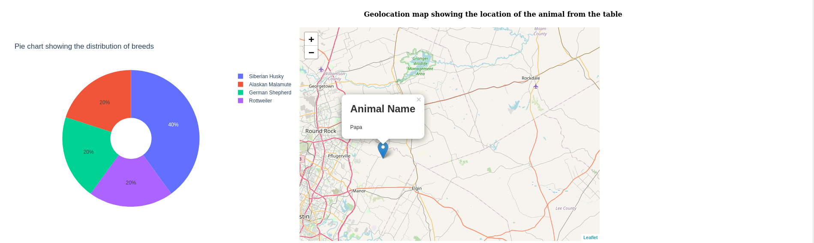

Filter type – Disaster Rescue/Individual Tracking:



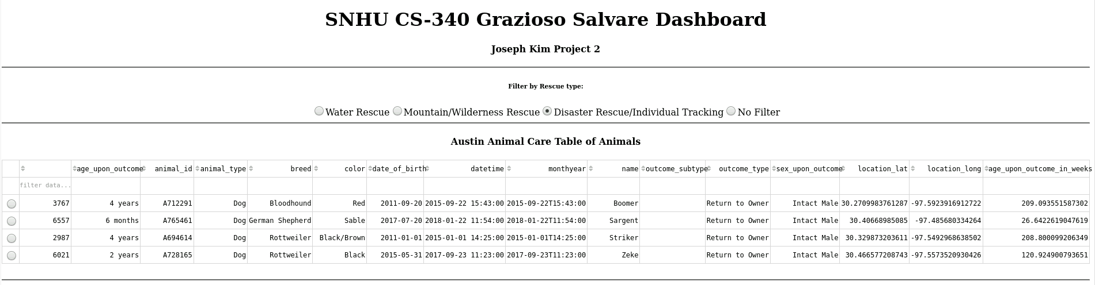

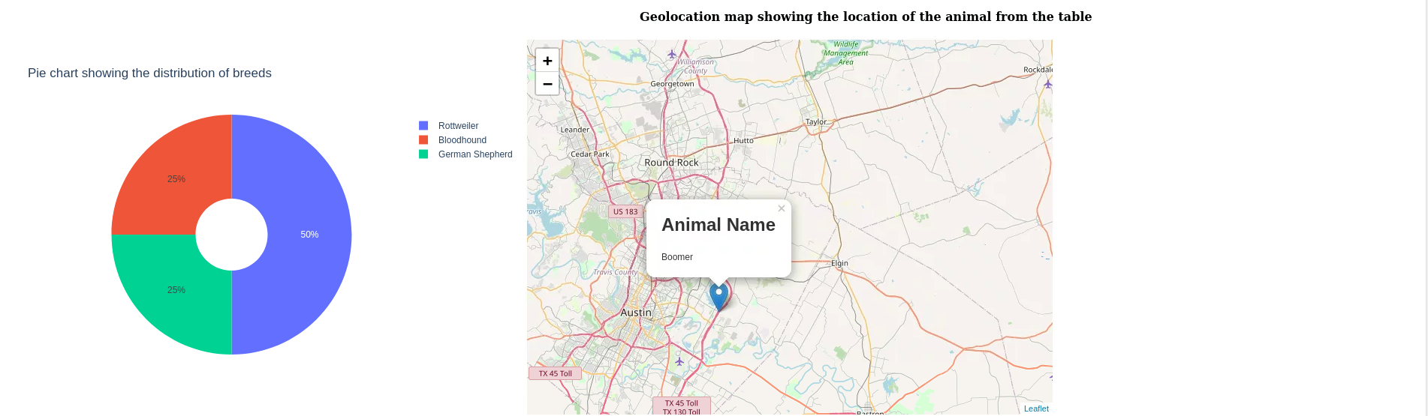

Filter type – No Filter, but with the 4th row selected:



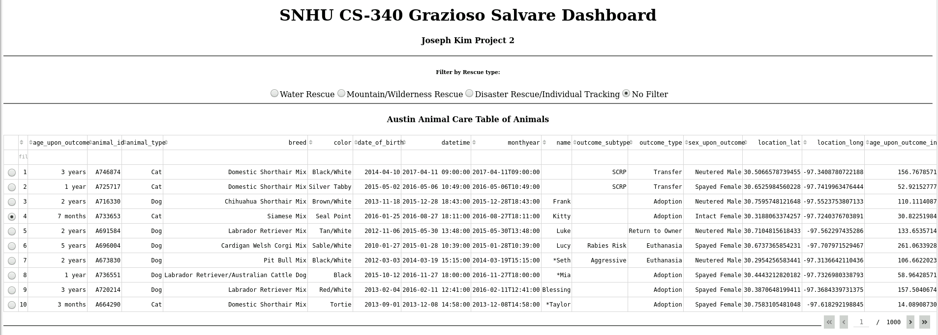

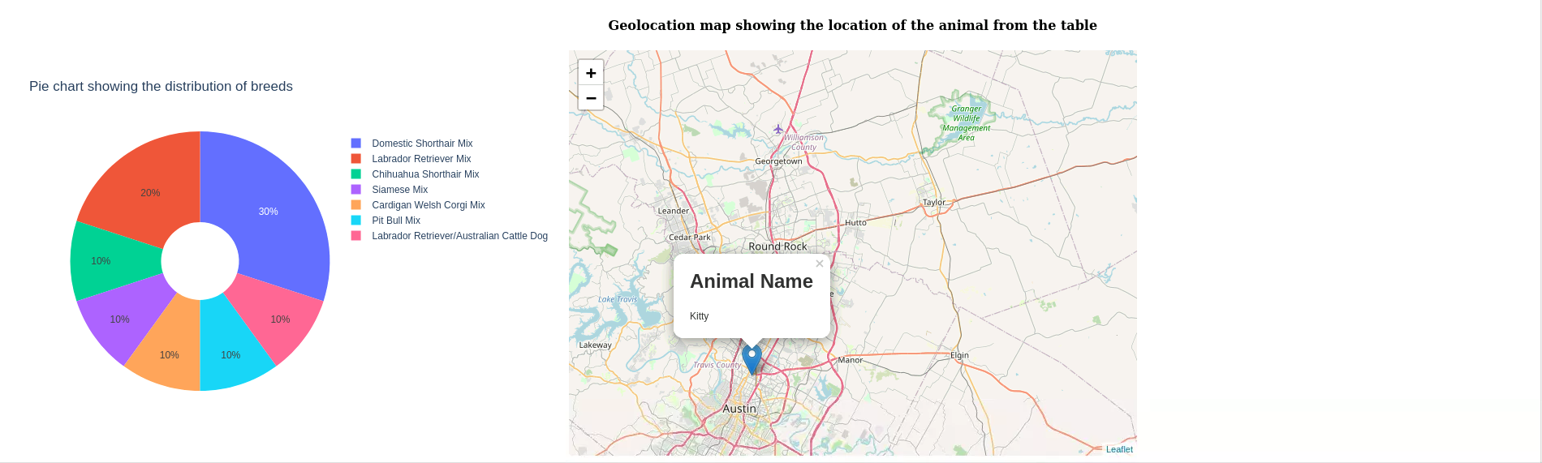

**Challenges**

The majority of my challenges were due to being unfamiliar with the html components and their syntax. I had to look up all of the app.layout html components and their attributes and the more difficult dash core components for the radio buttons and graphing components. I ran into another challenge when I tried to return a children as the component property for my graph. I thought I had to return a children component property based off of the starting code given for the geolocation map. However, after consulting the Dash documentation, I found that I should create a dcc.graph in the layout and then return a figure in the callback function. Another challenge I encountered was trying to pass into input from the filtered data table. I had to look into the documentation of component properties for a table to find that “derived_viewport_data” and “derived_virtual_selected_rows” existed for this purpose. I also had issues with the search query given from the module 7 quiz. After some search on examples of combining the $gte and $lte parameters, I changed the syntax for the age_upon_outcome_in_weeks query.

## Contact

Joseph Kim